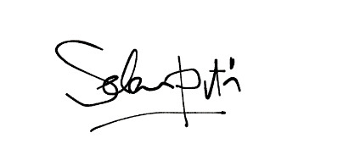

TO

**HIRING MANAGER**

John Travolta

Jl. Garuda Kav. 121 No. 45, Jakarta, ID

+62 21 9090 1234

john@gmail.com

Dear Mr. Travolta:

It is with great excitement that I forward my application for the position of Beauty Advisor with your team. With over 10 years of experience in the skincare and beauty industry and sales-based positions, I will bring a passion for problem solving and an expertise for innovation through team work. Throughout my entire career, I have demonstrated consistent success applying these aptitudes to achieve high-reaching standards and goals.

Here are some of the many strengths I can leverage to advance your company’s mission:

* Professional training in Makeup Artistry and as a Skin Care
* Comprehensive knowledge of luxury product lines, combined with an enthusiasm for cosmetic and skin healthcare trends
* A demonstrated ability to develop lasting relationships with customers and coworkers

Strong skills in consultative sales, inventory management, and goal attainment

My track record of success is outlined on the attached resume. I look forward the opportunity learn more about this opportunity and to discuss how I can contribute my strengths as a Beauty Advisor at Palm City Beauty. It is my goal to work with a team that shares my dedication to growth and advancement within the skincare and beauty industry.

I appreciate your taking the time to review my credentials and experience.

Sincerely,

SELENA PUTRI

Beauty Advisor

+62 274 9090 1234

selena@gmail.com

www.selena.com

Jl. Palagan No. 233, JOGJA, ID

SELENA

PUTRI

August 25, 2022

POSITION :

**Beauty Advisor**