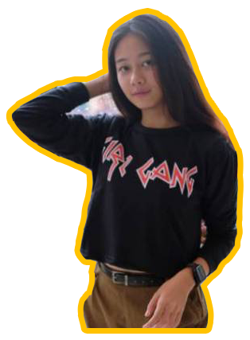

contact@merlyn-hy.com

twitter.com/merlyn

facebook.com/merlyn

Instagram.com/merlyn

**Contacts**

**Experience**

2019 Video Editor  
 Metro TV

2018 Professional Photographer  
 PT. Multimedia, Tbk

**Software**

Adobe  
InDesign

Adobe  
Lightroom

Adobe  
Premier Pro

Adobe Illustrator

Adobe Photoshop

S1 Broadcasting

Jl. Kapten Tendean No. 25  
Jakarta Selatan, 10200

+62 123 456 7890

28/06/1995

S2 Magister Desain

**About me**

**Fill about you here _______  
_______________  
_______________  
_______________  
_______________  
_______________**

PHOTOGRAPHER  
&

DESIGNER